Video Consultation (Near Me): Clinician Guide
Required
Hardware:
- Computer/tablet/smart phone
- Headset
- Compatible camera for device
- Internet connection
Note: if using NHS Lothian desktop computer you are able to use any plug and play device that does not require drive installation

Software:
- Operating system
  - Microsoft/iOS/Android
- Internet browser
  - Google chrome or Safari (WILL NOT WORK WITH INTERNET EXPLORER)
Note: if using an NHS Lothian computer you will require Chrome to be installed please follow the link for instruction (for Vision Practices Chrome must be installed on your blue screen)
http://intranet.lothian.scot.nhs.uk/Directory/GMSFacilitators/Useful%20Information/Pages/NHS-Near-Me-Guides.aspx

Other:
- NHS Lothian central server username and password
- Near Me username and password

How appointments are booked
- Admin staff will screen all requests for appointment for appropriate presentations that can be offered a Near me consultations
- They will ensure the patient has the correct hardware for a Near Me consultation and send them a link via SMS (through Bluebay in Vision)
- Patients will be instructed to try logging on before their appointment to check for any technical issues
- If they log in successfully they will be placed in a virtual waiting room
- If they have any issues they are instructed to call back the practice and the GP will be informed the appointment has changed to a telephone consultation
- Patient will also be informed that this follows the same rules as regular face to face appointment and if they are late or forget this it will be notes as a missed appointment
Note: A full representation of patient flow through the practice can be found in Appendix A

How to use Near Me (NHS Lothian desktop computers)

- Check both camera and headset are connected to USB ports and are set as default camera/speaker and microphone on your computer
- Open Chrome browser (on blue screen if a vision practice)

Note: if you are using 2 screens, ensure to open Vision
through the “Vision 1 Screen” icon to allow 1 monitor to
display Vision and the other the blue screen
- Open patient record on another tab/screen
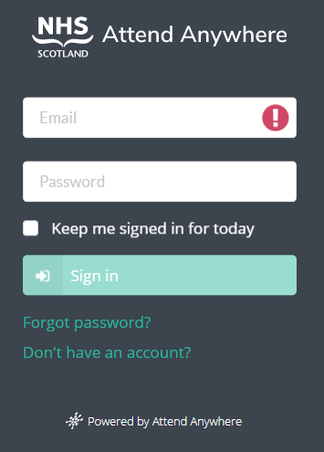
Note: if you are using a single screen you can restore down the patient record and Chrome browser setting each to half of the screen to be able to visualise both at once. This can be achieved by clicking and dragging each window to the end of the edge of the screen on the desired side
- Sign into Near Me platform in Chrome browser using the web address: https://nhs.attendanywhere.com/login
- This will take you to the waiting room:
  - A = Patient waiting area
  - B = Web address for patient
  - C = Test equipment
  - D = Calls begin with
  - E = New caller alerts
  - F = Account (profile/role/password change/sign out)
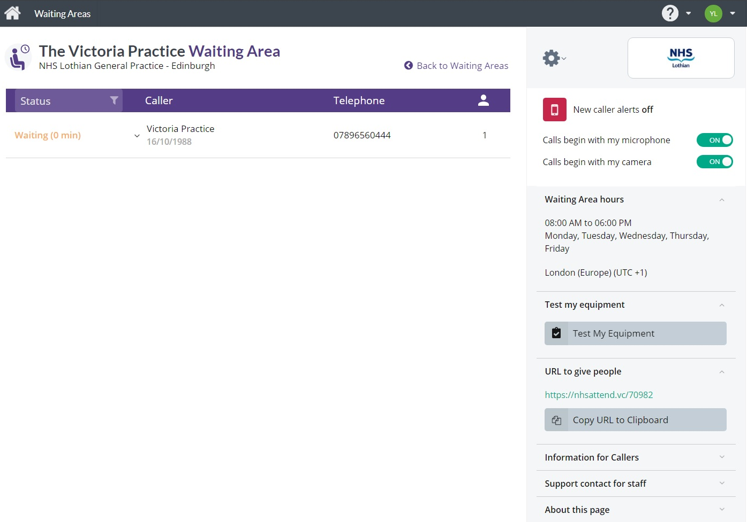
A
F
E
D
B
C
- Use the “Test Equipment” function to check your internet connection, video, audio and microphone are working correcting as well as camera positioning
- Patient will appear in the waiting area
Note: they will appear in the order they sign on so and not appointment time so please check it is the correct patient
- Select the patient with which you wish to start a video call. Once you left click you will be given three options:
  - Join call – open a video consultation with the patient
  - Notify - message the patient without opening up a video consultation
  - Call activity – information about this call
  - Participants
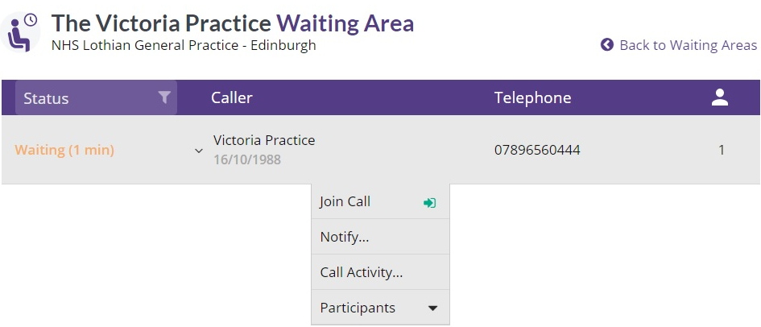
Note: Video consultations will start with the options based from the “Call begin with” options as selected from the main waiting room
- The video consultation will open in a new window. It can take up to 10 seconds for the connection to fully load. Please be patient, there if generally at least a few seconds delay. Once loaded you can begin you consultation.
- There are several option along the video consult screen
- Chat – send messages to the patient that will appear on their screen
  - Useful to share information or is there are any technical difficulties such missing audio
- Mic - turn your microphone on/off
- Camera – turn your camera on/off
- Share screen – share you screen with the patient (requires additional add on)
- Invite – invite another caller to the consultation
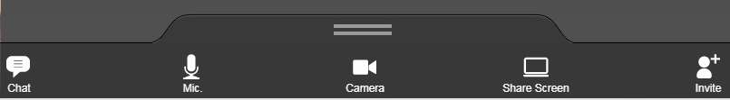
  - Can be useful for family members/additional clinician or interpreter. A link can be sent by SMS or email within the system copied to another platform to be sent.

- Once you have completed your consultation move the mouse to the top of the screen and options will appear in the top right
  - Settings wheel – select camera/headphone/microphone input
  - Refresh – Refresh video consultation window
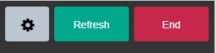
  - End – options for finishing video consultation
- You will be presented with three options if you click “End”:
  - No, don’t disconnect me – returns you to the call
  - Disconnect only me – removes you form the call resulting in 1 of two options:
- Leaving the patient with any invited third party
- Patient returns to waiting room
  - Disconnect me and end video call – closes the call for both you and the patient
- Record clinical notes as per usual using “TeleHealth” clinical code

Three Way Calls
As shown above a three way call can be initiated within an open video consultation however it may be more efficient to have both parties already in the waiting room.
To do this you:
- Request all parties to enter the waiting room using the web link for the practice
- “Join call” with one of them to open a video consultation window
- Click on the Chrome browser button along the bottom to take you back to the waiting room
- Click on the third party and click “add to call”

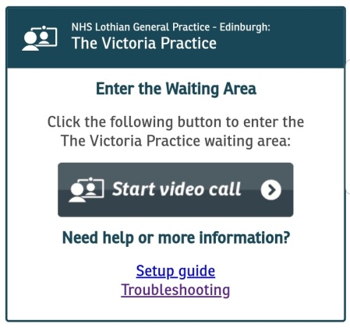
Patient Experience
- Patients log on through web address: https://nhsattend.vc/70982
- They must click start “Start Video Call” and will be taken to another page where they must enter their first name, surname, date of birth and phone number
Note: this is the name that will appear in the patient waiting area so if for a child they should sign in with their child’s name to avoid confusion
- Once a video call is started they will have several options along the bottom of their screen:
  - Chat – send a message to the clinician that will appear on your screen
  - Switch Cam. – switch between the front facing and rear facing camera on most mobiles or other camera options if a different device
  - Mic. – turn microphone on/off
  - Camera – turn camera on/off
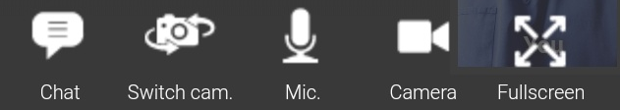
  - Fullscreen – make the video consultation fullscreen

Trouble shooting
- Audio/microphone not working?
  - Check you have loading Near Me on the bluescreen if using vision and not the green
  - Open the Audio controls and check your headset is currently selected as default
    - Audio controls can be found through the windows control panel or the speaker symbol bottom right corner of the screen (blue screen in Vision)
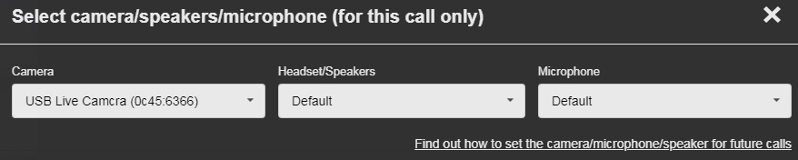
  - In the video consultation window click the settings wheel in the top right corner which will bring up the box shown below and ensure the right camera and headset/speakers and microphone are selected
  - If you have an open video consultation click “refresh” and ask the patient to do the same (use chat function if they cannot hear you)
- Video frozen?
  - Click “refresh”
  - Check Internet connection
- Poor quality image?
  - If using a mobile try asking the patient to switch to the rear facing camera (will be a tab at the bottom of their screen)
    - Useful for better quality images of skin lesions
  - If the patient is connected to their WiFi and it is a bad connection if they have an adequate data plan they could try their mobile date and vice versa
- Working from home – difficulties using secure global desktop (SGD) and Near Me?
  - Load Near Me from you local device and not through SGD
  - Load Near Me on your phone and use another device to access SGD
- Near Me not loading?
  - Check using Chrome/safari and NOT internet Explorer
  - Check minimum operating requirements:
    - Windows PC with i5 processor and 3GB of RAM (Windows 7 or later)
    - Apple Mac with i5 processor and 3GB of RAM (MacOS 10.12 Sierra or later)
    - Android smartphone/tablet (Android 5.1 or later)
    - iPhone (iOS 11.4+)
    - iPad (iOS 11.4+, iPadOS 13+)
- Further trouble shooting can be found at: https://nhs.attendanywhere.com/callers/Content/C_Tasks/Troubleshoot%20Setup.htm

Appendix A – Current Patient Flow

